Candidate name: | Cheong Hao Shaun
Class: | 17SH08 1cz2A
Programming language used: | Python 3.6.0

Question 1
Evidence 1
Paste program code here
elec = open("ELECTIONS2017.TXT","r")
stats = []
for i in elec:
i = i[:4] #appends voted president without the '\n'
stats.append(i)

abcd = 0
wxyz = 0
voted = 0

for data in stats: #for every vote, check which president is voted
if data == "ABCD":
abcd += 1
voted += 1
elif data == "WXYZ":
wxyz += 1
voted += 1

per1 = int((abcd*100/voted*100000))
per2 = int((wxyz*100/voted*100000))

import math

round1 = str(math.ceil(int(str(per1)[2:5])/10)/1000)
round2 = str(math.ceil(int(str(per2)[2:5])/10)/100)

per1 = str(int(str(per1)[:2]) + float(round1))[:4]
per2 = str(int(str(per2)[:2]) + float(round2))[:4]

print("Sampled Votes:\t"+str(voted))
print("ABCD:\t"+per1+"%")
print("WXYZ:\t"+per2+"%")
president = ""
if float(per1)>float(per2):
president += "ABCD"
else:
president += "WXYZ"

print("Based on a random sample of "+str(voted)+", "+president+" would be elected")

Evidence 2
Paste screenshot here
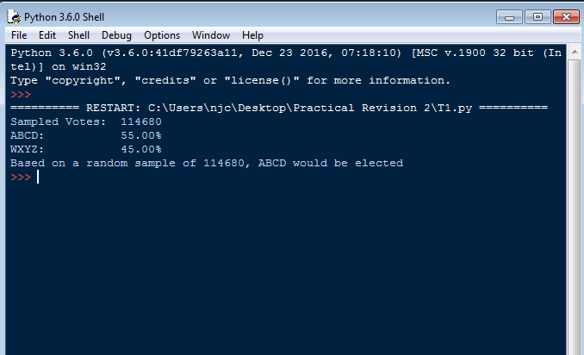

Evidence 3
Paste problem code here
elec = open("ELECTIONS2017.TXT","r")
stats = []
for i in elec:
i = i[:4] #appends voted president without the '\n'
stats.append(i)

def sampling():
samplez = int(input("Sample size: "))
if samplez=="0" or samplez>len(stats)-1:
print("Input valid sample size")
sampling()
else:
return samplez

sample = sampling()

import random

chosen_votes = []
chosen_vote_id = []

i=1
while i <= sample:
index = random.randint(0,len(stats)-1)
if index in chosen_vote_id:
continue
else:
chosen_vote_id.append(index)
chosen_votes.append(stats[index])
i+=1

abcd = 0
wxyz = 0

for data in chosen_votes: #for every vote, check which president is voted
if data == "ABCD":
abcd += 1
elif data == "WXYZ":
wxyz += 1

per1 = int((abcd*100/sample*100000))
per2 = int((wxyz*100/sample*100000))

import math

round1 = str(math.ceil(int(str(per1)[2:5])/10)/1000)
round2 = str(math.ceil(int(str(per2)[2:5])/10)/100)

per1 = str(int(str(per1)[:2]) + float(round1))[:4]
per2 = str(int(str(per2)[:2]) + float(round2))[:4]

print("Sampled Votes:\t"+str(sample))
print("ABCD:\t\t"+per1+"%")
print("WXYZ:\t\t"+per2+"%")
president = ""
if float(per1)>float(per2):
president += "ABCD"
else:
president += "WXYZ"

print("Based on a random sample of "+str(sample)+", "+president+" would be elected")

Question 2
Evidence 4
Paste program code here
def Menu(read,student):
print("\n"*5)
print("1. Read File Data\n2. Enter Additional Data\n3. Rank via merge sort\n4. End")
option = input("\n>> ")
incorrect = True
while incorrect:
if option not in ["1","2","3","4"]:
print("Enter a valid option\n")
else:
incorrect = False

Evidence 5
Paste program code here
def Menu(read,student):
print("\n"*5)
print("1. Read File Data\n2. Enter Additional Data\n3. Rank via merge sort\n4. End")
option = input("\n>> ")
incorrect = True
while incorrect:
if option not in ["1","2","3","4"]:
print("Enter a valid option\n")
Menu(read,student)
else:
incorrect = False

if option == "1":
if read == True:
print("Not allowed.")
Menu(read,student)
else:
RFD()
if option == "2":
if read == False:
print("Not allowed.")
Menu(read,student)
AddData(student)
if option == "3":
if read == False:
print("Not allowed.")
Menu(read,student)
Merge()
if option == "4":
print("End.")

def RFD():
f = open("DATA.TXT","r")
student = []
for line in f:
student.append(line.split())
f.close()
print("DATA HAS BEEN READ")
read = True
Menu(read,student)

def AddData(student):

nric = input("Please input the Student NRIC: ")
q1 = int(input("Please input the Quiz 1 Score (max 25): "))
q2 = int(input("Please input the Quiz 2 Score (max 35): "))
q3 = int(input("Please input the Quiz 3 Score (max 50): "))
new_data = [nric,q1,q2,q3]
student.append(new_data)

f = open("DATA.TXT","a")
data_line = ""
for i in new_data:
data_line += str(i) + " "
f.write(str(data_line)+"\n")
f.close()

cont = input("Enter More Data? (Y/N) ")
if cont.lower() == "y":
AddData(student)
else:
Menu(read,student)

Evidence 6
Paste program code here
def Merge(student):
calculate(student)
mergesort()

def calculate(student):
student_score = []
for i in student:
percentage = ((20*(int(i[1])/25))+(30*(int(i[2])/35))+(50*(int(i[3])/50)))
student_score.append(percentage)
def mergesort():
print("ehhhhhhhhhhhhhhhh")

Evidence 7
Paste screenshot here

